


Homework Sheet: Monday 13th April -Friday 17th April
Reminders: Your child needs to bring their swimming kit in on Wednesday please.

Spellings: -ous suffix

Mrs Homewoods, Mrs Goddard’s and Miss Mansi’s group | Mrs Rees-Winter’s group
Hideous | Curious
Fabulous | Serious
Humorous | Famous
Glamorous | Jealous
Courageous | Enormous
Outrageous | Obvious
Mountainous | Dangerous
Nauseous | various
Marvellous
tremendous
Spelling test on Thursday 23rd April

Times Tables
Division practice: 7 and 4 timetables:
28 ÷ 4 =
49 ÷ 7 =
24 ÷ 4 =
42 ÷ 7 =
44 ÷ 4 =
36 ÷ 4 =
21 ÷ 7 =
56 ÷ 7 =
32 ÷ 4 =
40 ÷ 4 =
63 ÷ 7 =
84 ÷ 7 =

Reading Please make sure you read at least 3 times a week, and hand your reading record in on a Monday.

Spelling practice space:
Half Term Project Half Term Project:
Our geography topic for this half term is the South of France. Please create a poster all about the South of France!
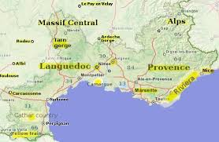

This Week’s Learning
English
Challenge:

English:
This week in English, we have started our new unit. We will be writing a non chronological report all about ‘Play’ and how important it is. We will then share this with year 3, in preparation for Year 4.
Challenge: Create a game that you would like to play. It could be an outdoor game or an indoor board game. Think about: Is it in teams? How do you win? Does it have a name? How would it benefit you as a player; EG Does it help keep you physically fit? Does it build communication skills or teamwork?
You can draw or write about your game below.

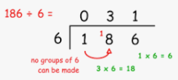
Maths
This week in maths, we have been learning short division, or you may know it as the ‘bus stop method’.
Challenge:
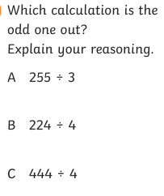
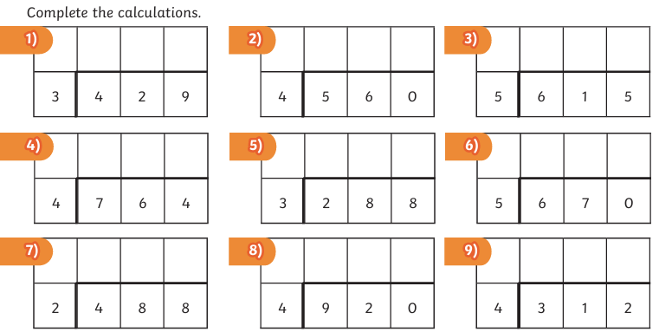
Topic: This week we had computing. We created a video about a topic of our choice using the google platform ‘vidz’. We added moving text, sound effects and background music!
Have a lovely weekend,
Year 4 team

