


Homework Sheet: Monday 20th -Friday 27th April
Spellings: Doubling the final consonant after a short vowel when adding -ing
Mrs Homewood, Mrs Goddard’s and Miss Mansi’s group | Mrs Rees-Winter’s group
Planning | Hoping
Begging | Hopping
Forgetting | Biting
Admitting | Batting
Expelling | Pining
Dining | pinning
Creating
Mistaking
Refining
residing
Spelling test on Thursday 30th April

Reminders: Children will need to bring their swimming kit in on Wednesday please.

Times Tables
Division practice: 7 and 4 timetables:
28 ÷ 4 =
49 ÷ 7 =
24 ÷ 4 =
42 ÷ 7 =
44 ÷ 4 =
36 ÷ 4 =
21 ÷ 7 =
56 ÷ 7 =
32 ÷ 4 =
40 ÷ 4 =
63 ÷ 7 =
84 ÷ 7 =

Reading Please make sure you read at least 3 times a week, and hand your reading record in on a Monday.

Spelling practice space:
Half Term Project Half Term Project:
Our geography topic for this half term is the South of France. Please create a poster all about the South of France!
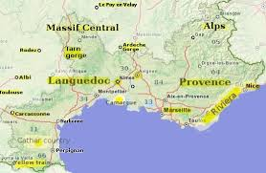

This Week’s Learning
English
Challenge:

English:

This week in English, we have continued learning about non-chronological reports. We have used fronted adverbials, to tell the reader ‘where, when or why’ and then we have looked at how a paragraph is formed and the structure it follows.

Challenge: Write 5 sentences using fronted adverbials about what you did over the weekend.
EG: On Saturday morning, I had gymnastics.
_____________________________________________________________________________________________________________________________________________________________________________________________________________________________________________________________________________________________________________________________________________________________________________________________________________________________________________________________________________________________________________________________________________
Maths

This week in maths, we moved on to time. We converted between 12hr and 24hr, and solved the duration on a number line.
Challenge:
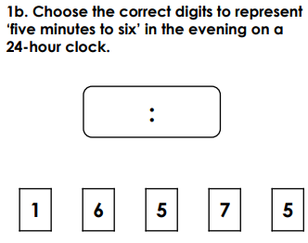
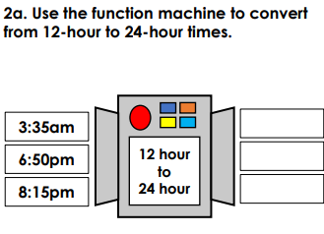

Topic:
This week we started our Science topic, Living things and their habitats.
So far, we have grouped animals using their characteristics.

Have a lovely weekend,
Year 4

