

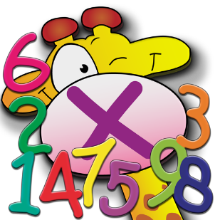
Homework Sheet: Monday 27th April – Friday 1st May
Spellings: Spell words containing the dʒ sound spelled ge and dge
Mrs Homewood’s and Miss Mansi’s group | Mrs Rees-Winter’s group (revisit)
Energetic | Bridge
Courageous | Hedge
Legendary | Ledge
Magician | Dodge
Generosity | Badge
Knowledge | fridge
Cartridge
Pledge
dislodge
judgement
Spelling test on Thursday 8th May

Reminders: Children will need to bring their swimming kit in on Wednesday please.

Times Tables
Division practice:
60 ÷ 12 =
84 ÷ 12 =
132 ÷ 12 =
48 ÷ 12 =
24 ÷ 12 =
120 ÷ 12 =
96 ÷ 12 =
108 ÷ 12 =
72 ÷ 12 =
36 ÷ 12 =
144 ÷ 12 =
12 ÷ 12 =

Reading Please make sure you read at least 3 times a week, and hand your reading record in on a Tuesday.

Spelling practice space:
Half Term Project:
Our geography topic for this half term is the South of France. Please create a poster all about the South of France!
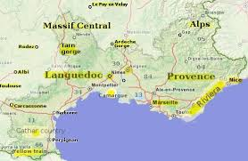

This Week’s Learning

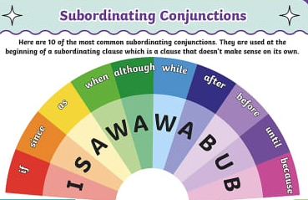
English
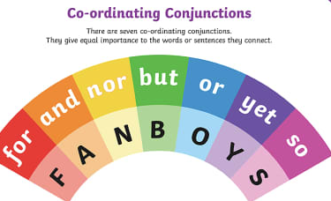
This week in English, we have continued learning about non-chronological reports. We have written multi-clause sentences and varied our non to pro-noun to keep our reader interested.
Challenge: Write 5 multi clause sentences below about what you did at the weekend.
___________________________________________________________________________________________________________________________________________________________________________________________________________________________________________________________________________________________________________________________________________________________________________________________________________________________________________________________________________________________________
Maths
In maths this week, we have focused on finding intervals of time and converting time from hours to minutes and from minutes to seconds. We would appreciate it if you would continue to practise telling the time with your children at home. Here are a couple handy websites to support this learning.

Maths Frame
https://mathsframe.co.uk/en/resources/resource/116/telling-the-time

BBC BITESIZE
https://www.bbc.co.uk/bitesize/topics/zhk82hv/articles/zsvbp4j

Please also remember to practise times tables!

https://www.topmarks.co.uk/maths-games/hit-the-button

https://www.timestables.co.uk/

Have a lovely long weekend!
Year 4

