


Homework Sheet: Monday 11th – Friday15th May
Spellings:
Mrs Homewood’s and Miss Mans’s group | Mrs Rees-Winter’s group
Boutique | No set spellings. Practise year three and four statutory spelling words.
Unique
Antique
Picturesque
Grotesque
Critique
Cheque
Mosque
Opaque
mystique

Spelling test on Thursday 21st May

Times Tables
Division practice:
18 ÷ 9 =
27 ÷ 9 =
45 ÷ 9 =
90 ÷ 9 =
54 ÷ 9 =
81 ÷ 9 =
132 ÷ 9 =
99 ÷ 9 =
36 ÷ 9 =
63 ÷ 9 =
9 ÷ 9 =
72 ÷ 9 =

Reading Please make sure you read at least 3 times a week, and hand your reading record in on a Monday.

Reminders: Children need to bring their swimming kit to school on Wednesday please.

Spelling practice space:
Half Term Project:
Our geography topic for this half term is the South of France. Please create a poster all about the South of France!
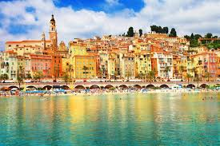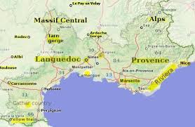

This Week’s Learning
English:
In English this week, we edited our non-chronological reports, created a glossary and then wrote them up in our neatest handwriting.
Challenge: Edit the sentences below so they have all the correct punctuation, spellings and are grammatically correct.
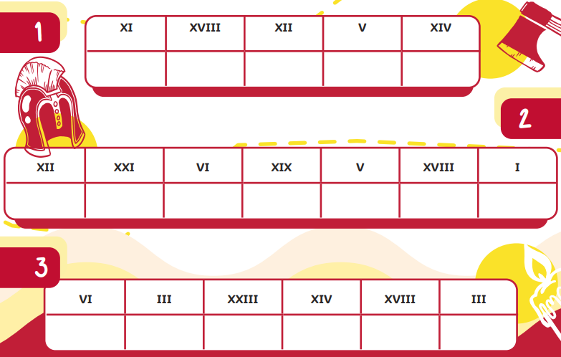
Maths
________________________________________________________________________________________________________________________________________________________________________
________________________________________________________________________________________________________________________________________________________________________
________________________________________________________________________________________________________________________________________________________________________
In maths, we have been learning all about Roman Numerals.
Challenge:
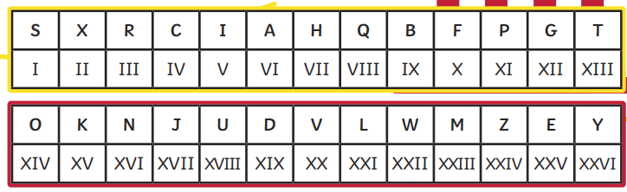
Foundation Subject
This week, we started our geography topic ‘The South of France’. So far, we have located France on a map, compared the location in Europe to other countries using directional language and discussed the different landscapes in the region.

Have a lovely weekend,
Year 4 team

