


Homework Sheet: Monday 22nd- Friday 26th June
Spellings:

Mrs Homewood & Miss Mansi’s group | Mrs Rees Winter’s group
answer | here
calendar | there
centre | where
certain | they
favourite | were
pressure
natural
probably
regular
surprise
Spelling test on Thursday 2nd July

Times Tables
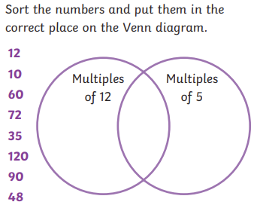
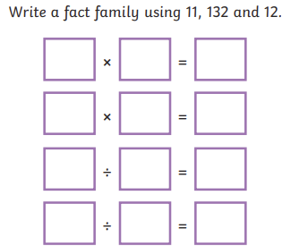
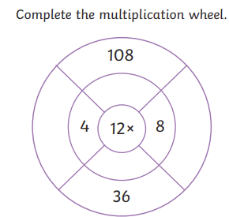

Reading Please make sure you read at least 3 times a week, and hand your reading record in on a Monday.

Reminders: Can you bring in the following items for our future DT topic: Hummus style plastic pot with a lid.

Spelling practice space:
Half Term Project:
Our Science topic this half term is We are Scientists! We would like you to research a Scientist and tell us all about them. This could be in the form of a poster, a booklet, a drawing or even a PowerPoint presentation. Be as creative as you like. Please return by Friday 10th July.

This Week’s Learning
English:
This week in English, we have worked on direct speech. We made sure our inverted commas and punctuation were all in all the correct place, we had a new line for a new speaker and we had an exciting reporting clause to reflect how the character was feeling.
. Challenge: Write a conversation between Chaya and Neel. Chaya has just arrived at the workshop with the jewels…

_____________________________________________________________________________________________________________________________________________________________________________________________________________________________________________________________________________________________________________________________________________________________________________________________________________________________________________________________________________________________________________________________________________________________________________________________________
Maths This week has been assessment week. All the children have worked really hard and should be proud of their achievements.
Foundation Subject
This week we looked at the Tudor Family tree and were introduced to Henry VIII and his 6 wives in preparation for our rescheduled trip to the Tower of London.

Friday School Closure: We have uploaded work to be completed at home. There is no obligation to bring this work into school on Monday. Please note – the rescheduled trip to the Tower of London is now on Monday 6th July 2026.

Have a lovely weekend and stay safe in the sun!
Year 4 Team

